  Time: 2 hrs 26/12/2015 | Chemistry of Paints and Coatings  416 chem. | Chemistry Department Faculty of Science  Benha University

الإجابة النموذجية لامتحان كيمياء تكنولوجيا البويات
416 ك
(ورقة امتحانية كاملة)

الفرقة : الرابعة
الشعبة : الكيمياء الخاص و الكيمياء التطبيقية
التاريخ : السبت 26 / 12 / 2015 ظهرا
الممتحن : د/ محمد عبد الرحمن موسى ابو ريا
قسم : الكيمياء
كلية : العلوم

1 – a) Write short notes on the types of solvents used in paints, and illustrate its properties.
Answer
A solvent should generally have the following properties:
1) Clear and colorless
2) Volatile without leaving a residue
3) Good long-term resistance to chemicals
4) Neutral reaction
5) Should also have an acceptable odor.
6) Anhydrous
7) Constant physical properties according to the manufacturers’ specification
8) Low toxicity
9) Biologically degradable
10) As inexpensive as possible
The solvents generally used in the paint industry may be divided into three classes: a. Hydrocarbon solvents
b. Oxygenated solvents
c. Water
Hydrocarbon solvents are the most commonly used solvents in paints to carry the pigment and binder. They are divided into three groups: aliphatic, naphthenic, and aromatic. The preferred type of solvent is an odorless aliphatic hydrocarbon (mineral spirits), which can be used in all areas including home. However, mineral spirits do not dissolve all binder resins.
The principal oxygenated solvents are ketones, esters, glycol esters, and alcohols. They offer much stronger solvency and are widely used as active solvents for synthetic binders. Ketones are characterized by their strong odor, range of water solubility, and evaporation rate.
Water is the main ingredient of the continuous phase of most emulsion paints. The advantages of water as a solvent are its availability, cheapness, lack of smell, nontoxicity, and no flammability. However, it is not an ideal paint solvent because of its limited miscibility with other organic solvents, and because film formers designed to be dissolved or dispersed in water usually remain permanently sensitive to water.
b) Mention only the ways of paint drying takes place.
Answer
Drying of the paint on the substrate takes place physically (1- 3) or chemically (4):
1) Evaporation of the organic solvents from solvent-containing paints
2) Evaporation of water from waterborne paints
3) Cooling of the polymer melts (powder coatings)
4) Reaction of low molecular mass products with other low or medium

c) What is the importance of acrylic coatings?
Answer
Acrylate resins have several advantages over other paint binders:
1) Polyacrylates are only slightly attacked by chemicals, and confer a high degree of resistance to paints.
2) Polyacrylates are colorless, transparent, and do not yellow, even after prolonged thermal stress.
3) Polyacrylates do not absorb above 300 nm and are therefore not degraded by UV radiation (as long as they do not contain styrene or similar aromatic compounds).
4) Polyacrylates do not have unstable double bonds.
5) Polyacrylates have outstanding gloss and gloss retention.
6) Acrylates, and especially methacrylates, are stable to hydrolysis long as they do not contain styrene or similar aromatic compounds.

- a) How can you prepare waterborne alkyds?
Answer
1) Alkyd resins with high acid numbers (> 50) are neutralized with amines (normal air-drying resins have an acid number < 10, oven-drying resins 20-35); solubility in water is due to salt formation
2) Alkyd resins are emulsified in water after addition of emulsifying agents and stabilizers or after chemical modification with special monomers e.g. polyglycols.
3) Alkyd Resins with High-Solids content. Alkyd resins have been developed for producing high-solids paints to reduce solvent emission.
b) Write short notes on: (6 Marks)
- Acrylic coatings.
- Classify the alkyd coatings according to its oil length or fatty acid content.
Answer
- Acrylic coatings.
Polyacrylates as binders consist of copolymers of acrylate and methacrylate esters. Other unsaturated monomers (e.g., styrene and vinyl toluene) may also be incorporated, but usually to a lesser extent. Copolymers formed exclusively from acrylates and/or methacrylates are termed straight acrylics.
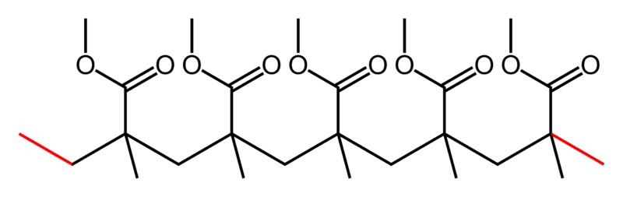

Skeletal formula of a short length of a polymethyl methacrylate chain
The resin products may be solids, solutions in organic solvents or water, emulsions, or dispersions.
Acrylate resins have several advantages over other paint binders:
1) Polyacrylates are only slightly attacked by chemicals, and confer a high degree of resistance to paints.
2) Polyacrylates are colorless, transparent, and do not yellow, even after prolonged thermal stress.
3) Polyacrylates do not absorb above 300 nm and are therefore not degraded by UV radiation (as long as they do not contain styrene or similar aromatic compounds).
4) Polyacrylates do not have unstable double bonds.
5) Polyacrylates have outstanding gloss and gloss retention.
6) Acrylates, and especially methacrylates, are stable to hydrolysis long as they do not contain styrene or similar aromatic compounds.
- Classify the alkyd coatings according to its oil length or fatty acid content.
Answer
According to the oil or fatty acid content, the alkyds are divided into three broad categories:
• Short oil (to 40 percent)
• Medium oil (40-60 percent)
• Long oil (more than 60 percent) alkyd resins
Oil length | Oil content % | Phthalic anhydride
Short  Medium  Long  Very long | 35-45  46-55  56-70  71 up | > 35  30 – 35  20 –30  < 20
3- a) Discuss the two stages for the manufacture of alkyd resins.
Answer
The manufacture of the alkyds proceeds in two stages. 1- Monoglycerolysis, Pentaerythritol and vegetable oil are first heated with the catalyst for about two hours at 270ºC. The vegetable oil is an ester of glycerol and long chain unsaturated fatty acids, and the reaction is a trans-esterification, the fatty acids forming an ester with the polyhydroxy-alcohol pentaerythritol. Di- and tri- esters of PE and di- and monoglycerides are also presumably formed.
2- Esterification, After cooling the mixture to 150ºC, a slight excess of phthalic anhydride is added and the mixture is reheated to 240ºC where it is held for several hours while the polyester alkyd resin is formed:

b) There are many types coating's additives, discuss two types only of them.
Answer
1. Surface Additives:
Many surface defects can be explained by differences in interfacial tension. Poor substrate wetting, for example, must be expected if the paint has a higher surface tension than the substrate to be coated. When spray dust or solid dust particles fall onto a freshly coated surface, craters are formed if the deposited droplets or particles have a lower surface tension than the surrounding paint material. Craters are also formed if the surface to be coated is locally contaminated with substances having a very low surface tension (e.g., oils) and the surface tension of the paint is too high to wet these contaminated areas.
Silicone additives (mainly organically modified methylalkyl polysiloxanes) lower the surface tension of coatings and minimize surface tension differences.
- Driers and Catalysts:
Driers are used in paint systems that dry at ambient temperature by oxidation processes. They accelerate the drying process by catalyzing the autoxidation of the resin. Driers are in general organometallic compounds (metallic soaps of monocarboxylic acids with 8-11 carbon atoms), the metal being the active part.
Cobalt and manganese (primary or surface driers), lead, calcium, zinc, zirconium, and barium (secondary or through driers) are mainly used. In practice, mixtures of metallic soaps are commonly used to obtain the optimum ratio of through drying to surface drying. Secondary driers cannot be used on their own; they always have to be combined with primary driers.
Driers can cause skin formation during paint storage, particularly if the can or container has been opened. Oximes or alkylphenols are added as antiskinning additives.
They block the action of the driers in the can, but at the correct dosage do not prolong the drying time of the applied paint film due to their volatility.
The curing of coatings that are cross-linked by other chemical reactions can be accelerated with catalysts. Acid catalysts are the most important and are used for a large number of stoving enamels and force-dried, acid-curing wood paints. They are mostly sulfonic acids of widely varying structure, often blocked with amines to allow formulation of storage-stable paints. The use of a catalyst can lower the stoving time and/or stoving temperature to save energy or to permit the coating of temperature sensitive substrates.
- a) Write short notes on two types of Binders and resins.
Answer
- Vinyl Coatings:
This section deals with paints based on vinyl resins (including vinyl copolymers) which are synthesized by polymerization of monomers containing terminal CH= CH groups. Polyolefins, poly (viny1 esters), poly (viny1 alcohol), and polystyrene. Paints and coating materials based on vinyl resins are generally physically drying.
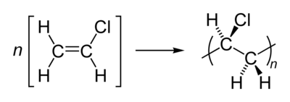
Only in a few cases vinyl resins can be chemically cross-linked with other reactants via incorporated reactive groups. The properties of the paints are therefore primarily determined by the chemical and physical nature of the vinyl resin. Polyvinyl chloride is produced by polymerization of the monomer vinyl chloride, as shown:

All vinyl resins have a linear carbon chain with lateral substituents and exhibit a range of molecular masses. Increasing molecular mass is accompanied by improved mechanical properties, a decrease in solubility, and an increase in the viscosity of their solutions. Vinyl resins of high molecular mass can therefore only be used in the form of dispersions or powders for paint applications. Solvent-containing paints require vinyl resins of considerably lower molecular mass than plastics, since only then sufficient binder content can be achieved in the viscosity range required for paint application.
Saturated Polyester Coatings:
Polyester resins are condensation products of di- or polyfunctional monomers containing hydroxyl groups and carboxyl groups. The development of saturated polyesters began in 1901 with “Glyptal resins”, formed from glycerol and phthalic anhydride (Smith, United States). Soluble resins obtained with fatty acids were first employed in 1925. Alkyd resins formed from unsaturated fatty acids can be cured by atmospheric oxidation.
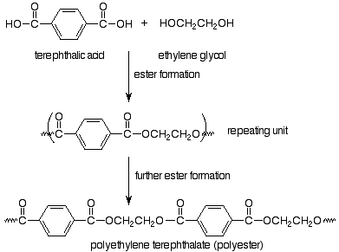
b) Write short notes on:
- The plasticizers.
- Oil based coatings.
- Pigments used in paints.

Answer
- Plasticizers:
Plasticizers are organic liquids of high viscosity and low volatility. The esters of dicarboxylic acids (e g, dioctyl phthalate) are well-known examples. Plasticizers work by embedding themselves between the chains of polymers, spacing them apart (increasing the "free volume"), and thus significantly lowering the glass transition temperature for the plastic and making it softer. Plasticizers lower the softening and film-forming temperatures of the binders. They also improve flow, flexibility, and adhesion properties. Chemically, plasticizers are largely inert and do not react with the binder components. Most binders used today are inherently flexible and can be regarded as "internally plasticized" resins. For this reason, use of plasticizers has declined.

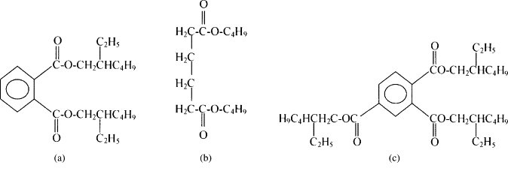
Structures of some traditional plasticizers:

(a) di (2-ethylhexyl) phthalate, (b) dibutyl adipate, (c) trioctyl trimellitate
ii- Oil based coatings.
- Oil paints consist of natural drying oils (e.g., linseed oil, or Tung oil, and soybean oil) which undergo autoxidative polymerization in the presence of catalytic driers and atmospheric oxygen.
- Environmentally friendly.
- Low viscosity.
- Oil paints are easily applied by conventional methods (e.g., brushing, roller coating, spraying, and dipping).
- Drying at room temperature in 12- 24 h depending on the amount of drier added, whereas several weeks are required in the vicinity of the freezing point of water.
- Pigments used in paints.
Pigments are insoluble, fine particle-size materials that confer on a paint its color and opacity. Both inorganic and organic substances are used, with the inorganic ones being in general cheaper but with less clear colours. Provide color
- Hide substrates and obliterate previous colors
- Improve the strength of the paint film
- Improve the adhesion of the paint film
- Reduce gloss
- Reduce cost
In general the following properties of pigments are important in selecting
a pigment for any particular product:
- Hiding power
- Tinting strength
- Refractive index
- Light-fastness
- Bleeding characteristics
- Particle size and shape
- a) Surfactants are very useful compounds and used in different industries in our life, illustrate its importance in coating industry.
Answer
Surfactants were used in different types of additives such as:
- Defoamers
- In Wetting and Dispersing agents
- As surface additives
Defoamers:
Defoamers (antifoaming additives) are liquids with a low surface tension which have to satisfy three conditions:
- They must be virtually insoluble in the medium to be defoamed.
- Lower surface tension, compared to organic antifoams
- Tends to react less with process ingredients
- Can cost less to use due to its effectiveness and persistence at low use levels.
5) They must have a positive penetration coefficient E
6) They must have a positive spreading coefficient S
E = δ_{L} - δ_{D} + δ_{L/D} > 0
S = δ_{L} - δ_{D} – δ_{L/D} > 0
δ_{L} = surface tension of the liquid phase
δ_{D} = surface tension of the defoamer
δ_{L/D} = interfacial tension between the liquid and the defoamer.
- Wetting and Dispersing Additives:
In the production of pigmented paints, the pigment particles must be distributed as uniformly and as finely as possible in the liquid phase. The pigment agglomerates must first be wetted by the binder solution. This process mainly depends on the chemical nature of the pigments and binders and can be accelerated by using wetting additives.
The Dispersing Process:
Pigment agglomerates are reduced in size during the pigment grinding phase; ideally this leads to the production of primary particles.
The various processes which occur during pigment grinding can be divided into the following three steps:
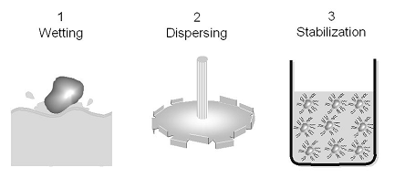
In the concluding step 3 (Stabilisation), the pigment dispersion must be stabilized in order to prevent the formation of uncontrolled flocculates. As described later, special techniques make it possible to keep the pigment particles at appropriate distances from one another so that they do not resume contact. In most applications the stabilization of the deflocculated condition is desirable.
Steps 1 (wetting) and 3 (stabilizing) can be influenced by additives. Wetting additives accelerate the wetting of pigment agglomerates by the resin; dispersing additives improve the stabilization of the pigment dispersion. One and the same product can oftentimes function as both the wetting and the dispersing additive.
Wetting additives are materials of low molecular mass with a typical polar-nonpolar surfactant structure; they reduce the interfacial tension between the binder solution and the pigment surface.
3. Surface Additives:
Many surface defects can be explained by differences in interfacial tension. Poor substrate wetting, for example, must be expected if the paint has a higher surface tension than the substrate to be coated. When spray dust or solid dust particles fall onto a freshly coated surface, craters are formed if the deposited droplets or particles have a lower surface tension than the surrounding paint material. Craters are also formed if the surface to be coated is locally contaminated with substances having a very low surface tension (e.g., oils) and the surface tension of the paint is too high to wet these contaminated areas.
Silicone additives (mainly organically modified methylalkyl polysiloxanes) lower the surface tension of coatings and minimize surface tension differences.
b) Discuss in brief the wetting and dispersing additives.
Answer
If this pigment grinding step is not optimized, then a wide variety of defects can occur:
• Flocculation
• Gloss decrease
• Color shift
• Flooding/floating
• Settling
• Viscosity instabilities
- These individual pigment particles are in contact with one another only along their edges and corners. Interactive forces between the particles are relatively small so that such forces can be overcome by traditional dispersing equipment.
- The various processes which occur during pigment grinding can be divided into the following three steps:
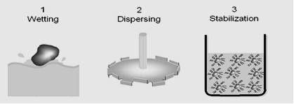
- Steps 1 (wetting) and 3 (stabilizing) can be influenced by additives. Wetting additives accelerate the wetting of pigment agglomerates by the resin; dispersing additives improve the stabilization of the pigment dispersion. One and the same product can oftentimes function as both the wetting and the dispersing additive.
- Wetting additives can be defined as substances which are designed to reduce interfacial tension and which, as a result, increase the “spreading pressure“ so that the wetting process is accelerated.
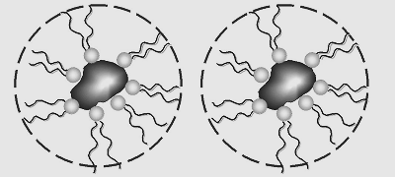
Dispersing additives are stabilizing substances that are adsorbed onto the pigment surface and establish repulsive forces between individual pigment particles. Stabilization is achieved either via electrostatic charge repulsion or via steric hindrance due to molecular structures that project from the pigment surface into the binder solution

